Plant deasise detection using EfficientNet

Zaid Abursheid , Zaid Ahram , Omar Azizie
Ibrahim Salah , Ahmad Al Monayer, Nour Alteeti

Supervised by: - Prof. Tamam Al Sarhan

Department of Information Technology ,Data science,University of Jordan ,Jordan
Year 2023

Abstract—This project addresses the challenge of plant disease detection across diverse plant species using EfficientNet. We leverage the Plant Village and Rice datasets to train a model capable of identifying 43 classes of plant diseases. Our approach involves transfer learning, fine-tuning the pre-trained EfficientNet on the combined dataset. We optimize for accuracy and efficiency, exploring data augmentation, regularization, and hyperparameter tuning. The proposed system demonstrates adaptability across different agricultural contexts, offering a valuable tool for early disease identification and precision agriculture, thereby contributing to global food security.

Introduction
Plant diseases are amongst the most dangerous to humans in an indirect way. 9 million people die every year due to starvation and over 14% of crop loss is due to plant disease. Prevention of such diseases starts with the identification of the type of disease.
Advanced techniques for identifying plant diseases are complex and numerous. This study compares and discusses them https://www.sciencedirect.com/science/article/abs/pii/S0168169910000438
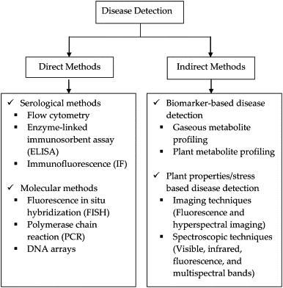

Figure 1-1 shows different plant disease detection techniques but all mentioned techniques are costly and require an expert to conduct them.

Herein, we propose the use of images of diseased plants to classify diseases in 43 different plants. The prediction approach depends on the collection of data that include the plant village and riceleaf. in order to process the data and extract meaningful information, we used efficientnet b3.

Our study not only merges 2 large datasets and includes a wide range of plant types and diseases but also uses algorithms never before used to solve this problem.

Datasets

Datasets play a crucial role in producing accurate results in deep learning. The quality and quantity of the data makes a huge difference in training deep learning models, the more the data the better. We used the Planet village (Hughes and Salathé, 2015) and Rice leafs (Vbookshelf, 2019) datasets. Planet village dataset is the most popular and publicly available dataset for researchers to make use of. Planet village dataset was published in 2015 it contains 14 plant species, 25 different diseases having early blight and late blight being the most common diseases, with around 61,000 images containing both healthy and infected plants with tomatoes being the most common species in the dataset. Inside the Rice leaf dataset there are around 3400 images. We merged these two datasets together to provide our model with a wider variety of plants and diseases to make it a robust model and applicable in real world scenarios.
We also made use of an augmented version of plant village dataset to provide us with more samples, (ARUN PANDIAN J,GEETHARAMANI GOPAL) contributed by augmenting the original dataset using different augmentation techniques, This increases the diversity within the data by creating variations in lighting, angles, scales and orientations which helps the model generalise better with unseen data. It also reduced overfitting by introducing randomness which makes it less likely for the model to memorize certain patterns in the training set.
https://www.kaggle.com/datasets/shayanriyaz/riceleafs
https://www.ncbi.nlm.nih.gov/pmc/articles/PMC10433211/
https://data.mendeley.com/datasets/tywbtsjrjv/1

Methodology
This model is based on efficient , a purely convolutional algorithm intended for image processing and introduced by Mingxing Tan and Quoc V. Le in 2019 in this paper https://arxiv.org/abs/1905.11946. The algorithm proposed a new scaling method that uniformly scales all dimensions of depth/width/resolution using a simple yet highly effective compound coefficient.
Efficinent net achieved one one the accuracy on Imagenet dataset despite of having lower parameters than other models compared with as shown in figure below.
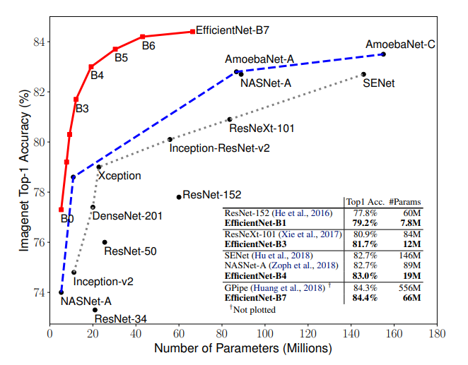

efficientnet focus on depth/width/resolution customization improves its utility as a convolutional neural network as shown in figure below . Our chosen hyperparameters were the default for efficientnet since they were tried and tested already and provided the best results

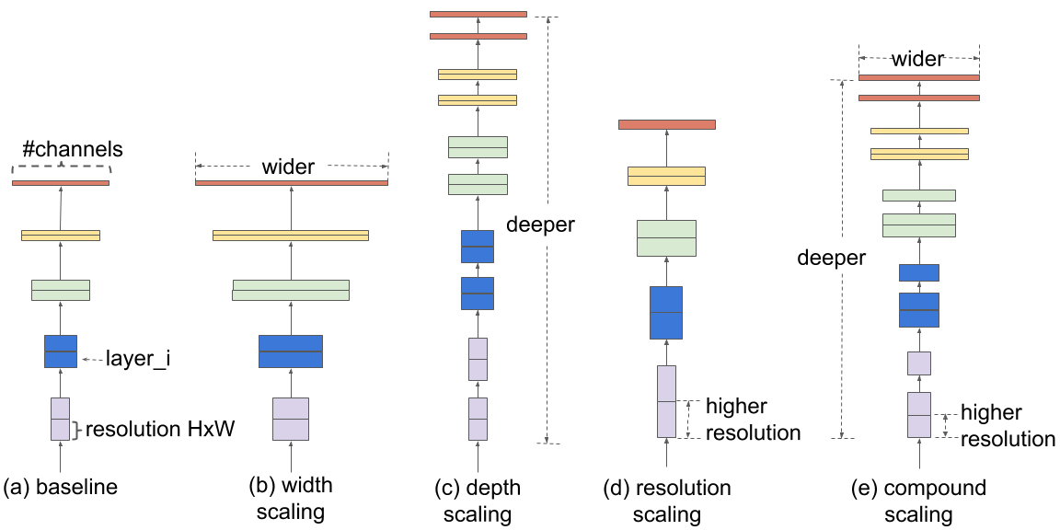

.

Each epoch took 28 minutes to complete and with 5 epochs our model ran for 140 minutes before completion. Even though we used transfer learning techniques due to our limited resources due to using open source Kaggle, our model still took multiple days to complete due to limits on daily cpu usage. Each epoch would be saved and used on the next run in a batch system combined with freezing layers.

We attempted to use efficientnet b7 but received no results on our first 3 attempts due to its complexity compared to efficientnet b3
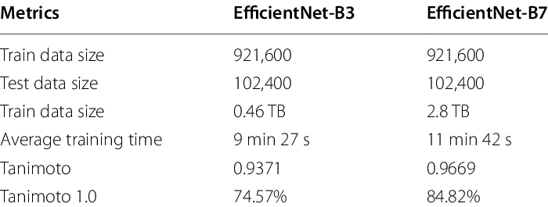

Figure 2-2 compares efficientnet b3 and b7. The figure shows the main difference between the two being both average training time with efficientnet b7 requiring more time and train data size being far larger at over 6 times larger than efficient b3’s. this could not be implemented due to the lack in resources.

Our study combines two large data sets being plantvillage and riceleaf. Combing the two provided 43 classes of plants for the model to train on consisting of over 54000 images in plantvillage and 120 in riceleaf. Furthermore, we augmented the images to create a larger dataset with a total augmented image count of 64841 augmented images with 61486 belonging to plant village and 3355 belonging to riceleaf making the grand total contain over 119000 images. This dataset is larger than any other plant disease data set that has been published in ML paper with 43 classes as opposed to the largest one published before this at 39.https://www.researchgate.net/publication/333538058_Identification_of_plant_leaf_diseases_using_a_nine-layer_deep_convolutional_neural_network

To overcome the lack of resources provided by the open source Kaggle we opted to change the formatting for all the images to RGB.

The split we chose was 80/10/10 being training/testing/validation respectively. this method proved very effective and provided us with the best results. The learning rate we chose was 0.01 which is the most recommended option.

Instead of using gradient decent we opted for Adam optimizer; stand for Adaptive Moment Estimation is a popular optimization algorithm used in training artificial neural networks It was introduced by Diederik P. Kingma and Jimmy Ba in 2014 in this paper https://arxiv.org/abs/1412.6980

The Adam optimizer combines the benefits of two other optimization algorithms: RMSprop (Root Mean Square Propagation) and Momentum. It maintains two moving averages for each parameter: the first moment (mean) and the second moment (uncentered variance). These moving averages are used to adaptively adjust the learning rates during training.

So even though we chose 0.01 as the default learning rate the learning rate continues to change as long as the algorithm is running

Discussion

In our study, we used the Efficientnetb3 model to make use of its advanced architecture and its ability to capture complicated features from images. Our study did an amazing job and performed very well compared to other results which accuracies range between 81.1% to 99.53% in plant diseases identification. The merging of plant village dataset and rice leafs dataset we introduced a new approach by diversifying the training data by adding more plant species and diseases. The approach that we did solves the challenges in other studies where models that are trained on a single dataset suffer from limitations when they are used in real world scenarios.
The usage of ImageNet’s pre trained weights contributed to the success of our model, it provided a strong foundation for feature extraction which enables the detection of patterns and features that is relevant to different fields including plant pathology. The use of ImageNet’s knowledge in our task helped the Efficientnetb3 model to generalize well on the merged datasets, which includes the Rice leafs dataset and the plant village dataset.
The decision to merge the Plant Village dataset and the Rice Leafs dataset was aimed to enhance the model’s adaptability to a wider range of plant species and diseases. By using a diverse set of plant species and diseases we aimed to create a more robust and versatile model, this approach is consistent with challenges identified in existing studies, where models trained on a specific dataset struggle when applied to real world scenarios with different environmental conditions and diverse plant species.
The stages and severity of the diseases can pose a challenge in accurate identification of the disease. The variability in accuracy rates as reported in other studies highlights the importance of refining models to detect subtle symptoms and early stages of diseases. Adding more datasets that cover a wider range of diseases stages can contribute to enhancing the model’s ability to identify diseases in their early stages.
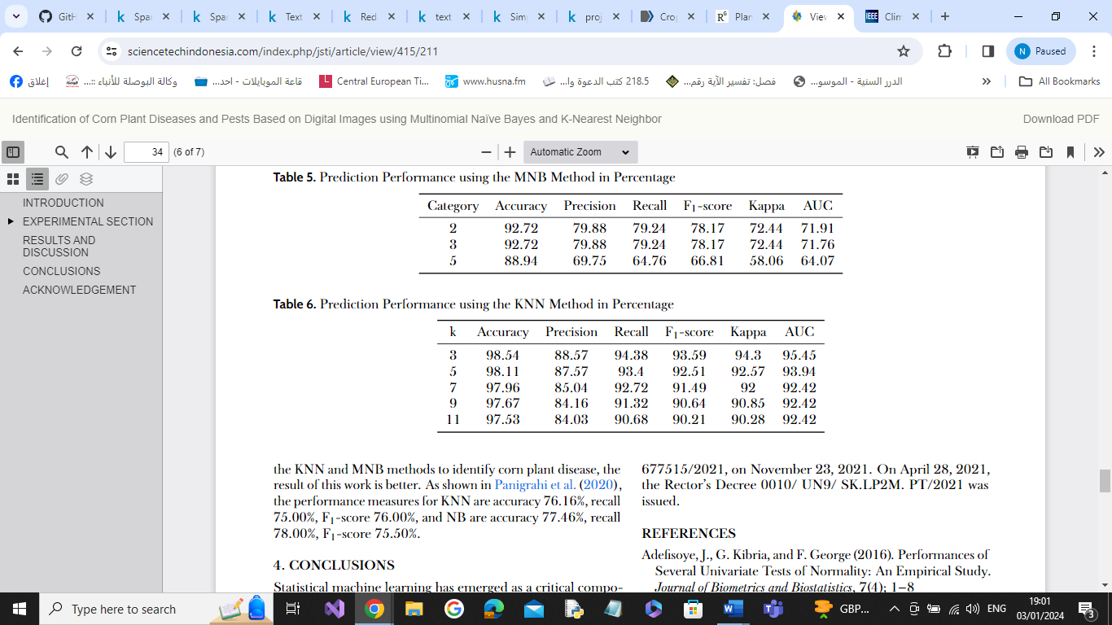
By leveraging the Efficientnetb3 model with the ImageNet pretrained weights and a merged dataset strategy, it will help future researches in plant disease detection. The success of our model highlights the importance of considering other models, pre-training and dataset diversity. The merging of multiple datasets will ensure robustness across different plants and diseases. Future researches should explore these aspects. As we try to unlock new paths that would advance plant disease detection these factors can move the field forward that would encourage the development of more accurate and efficient models to automate plant health monitoring
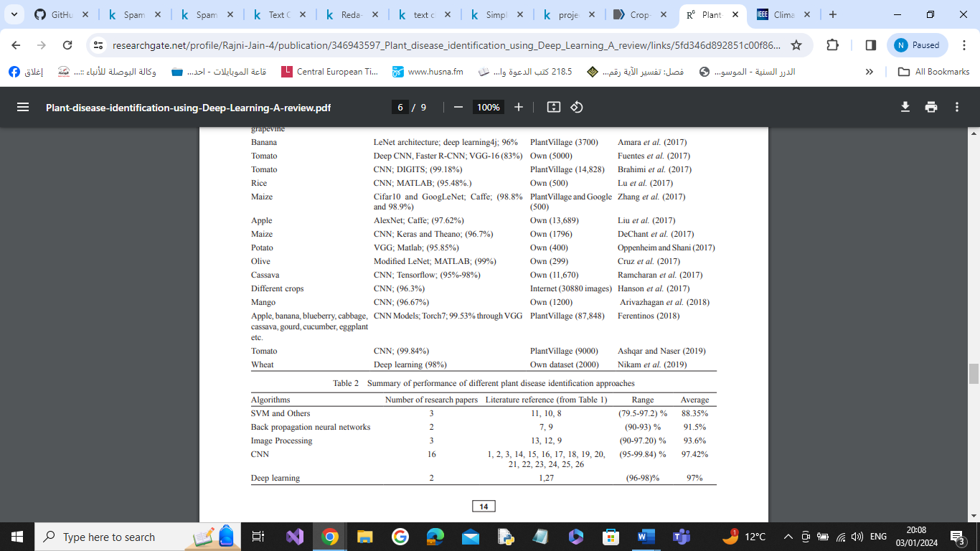
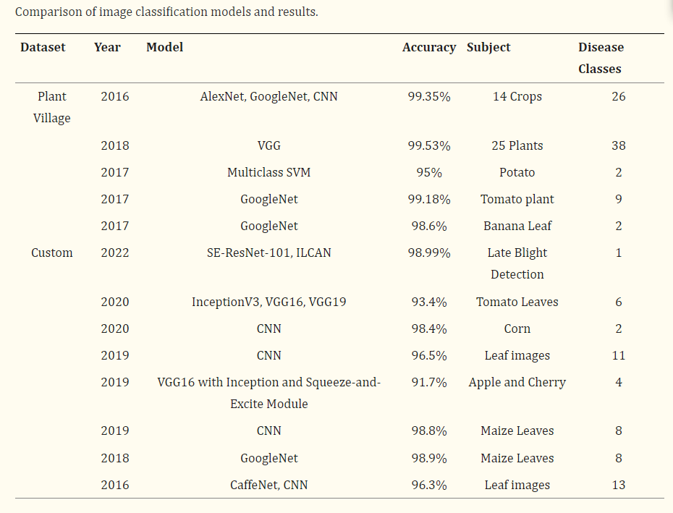

Related works
Many experts noticed this disaster and its significant increase Because of its effect on all living organisms ,they started their efforts and attempts from 1985 by (B.L. Upchurch et al ) , they designed a system for detecting apple damage based on its tissue ,they used ultrasonic sensor for detecting the damage .
Researchers conclude that sensor based detectors faced many limitations and challenges, such as: detecting manually which is absolutely not a practical method , there are many diseases ,cases and fruits we cant detect it from its tissue or using sensor based approaches.

Lately, researchers and who influenced in solving this problem, they tend to image processing and machine learning approaches, In (2010 T. Rumpf et al) the main contribution is the early detection for sugar beet diseases using support vector machine (machine learning approach), they were able to identify the disease of this plant before symptoms began to appear, and they were able to obtain an accuracy ranging between (65-90%).
(Jana Sperschneider et al) designed a model called (EFFECTORP)depending on Naïve Bayes, this is the first model for predicting fungal effectors, they achieve a sensitivity and specificity of more than 80%.
(Shima Ramesh et al) used random forest (machine learning approach) to classify the dataset that contains a healthy and diseased leaves, they conclude that random forest classifier is efficient in classifying large amounts of data in the field of leaf-based image classification.
(Yulia Resti et al) used Naïve Bayes and K-Nearest neighbour (KNN) to identify and classify corn diseases ,their dataset contained from 761 image and 6 diseases as features for the model, K-Nearest neighbour gave them an accurate results as shown in figure (1)

In 2019 (SAPNA NIGAM et al) made a comparison between various classification techniques(machine and deep learning approaches ), on different classes of dataset contained various types of fruits diseases, they conclude that machine learning models efficient when it is under limited circumstances, proving that deep learning techniques are more accurate and efficient, as shown in figure below.

There are many researches and projects used deep learning approaches such as:
1)Detecting diseases based on image classification :

In 2018, (Zhang et al) et al) attained accuracy levels of 98.9% and 98.8% by employing enhanced deep neural network structures, specifically GoogLeNet (InceptionV1) and Cifar10. Their strategy encompassed the integration of the Relu function, diversification of pooling operations, and fine-tuning of model parameters, all contributing to an improved precision in recognition accuracy.

In 2019, (Hang et al) utilized VGG16 with Inception and the Squeeze-and-Excite Module for the categorization of diseases in apple, cherry, and corn. They documented an accuracy rate of 91.7%, extending their findings to the broader context of the AI Challenger dataset.

In 2018, (Ferentinos) used AlexNet, AlexNetOWTBn, GoogLeNet, and VGG on the Plant Village dataset, achieving a remarkable classification accuracy of 99.53% across 38 classes .

(Zafar Salman) made a summary for many models based on image classification, as shown in figure 1

- Detecting disease based on object detection :

There are many models depends on object detection such as :
(Xiaoyue Xie et al ) implemented Faster R-CNN on the grape leaf disease dataset by utilizing InceptionV1, ResNet V2 and achieved accuracy of 81.1%.
(Mehmet Metin Ozguven et al)A modified Faster R-CNN architecture was introduced by adjusting the parameters of a CNN model, along with the development of a Faster R-CNN architecture specifically designed for the automated detection of leaf spot disease in sugar beets they achieved a classification rate of 95.4% .

(Zafar Salman et al) presented a summary for many models based on object detection as shown in figure bellow:

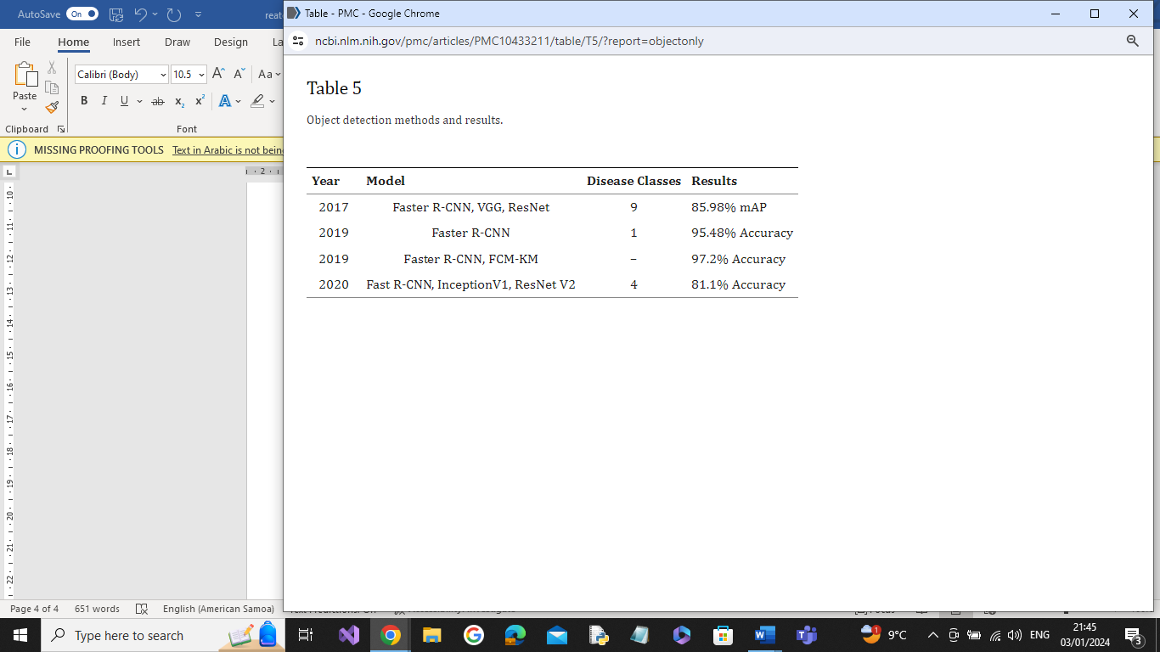

In this work, our contributions are as follows:

1)We used EfficientNet B3 that we are the first research used this model in this field, and designed a varies experiments in terms of accuracy , speed and computational complexity.

2)We collected various types of diseases plants that no participations collected such this huge and comprehensive dataset, it contained from 41 classes from different types of diseases.

Conclusion
In conclusion, our study leveraged the EfficientNetB3 model, incorporating its advanced architecture to achieve impressive results in plant disease identification. By merging the Plant Village dataset and Rice Leafs dataset, we introduced a novel approach that addresses limitations observed in models trained on single datasets, enhancing adaptability to diverse plant species and diseases in real-world scenarios.
The utilization of ImageNet's pre-trained weights played a crucial role in the success of our model, providing a strong foundation for feature extraction and enabling robust generalization across the merged datasets. Our strategy aimed to overcome challenges in accurately identifying diseases, especially at different stages and severities, emphasizing the importance of refining models to detect subtle symptoms and early stages.
Our contributions include being the first to use the EfficientNet B3 model in this field, conducting various experiments focusing on accuracy, speed, and computational complexity. We compiled a comprehensive dataset comprising 43 classes of different diseases, showcasing the diversity and depth of our research.
Despite facing limitations, such as memory constraints on Kaggle accelerators and repetitive crashes, our model achieved a noteworthy accuracy of 94%.
, demonstrating its effectiveness within the given constraints. The use of Tensor Processing Units (TPUs) and Just-In-Time (JIT) implementation by TensorFlow addressed memory limitations and expedited training while maintaining efficiency.
Our hyperparameter choices, including Adam optimizer, a learning rate of 0.01, and 5 epochs of training, contributed to the success of our model. During testing, we achieved a 94.7% accuracy and 1.1601 loss, emphasizing as shown in figures bellow
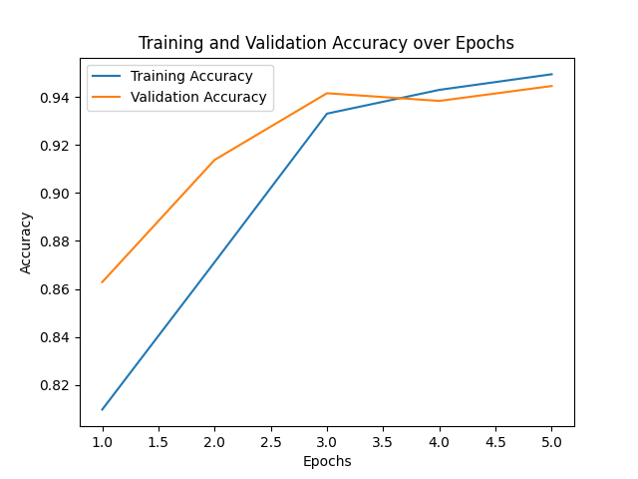
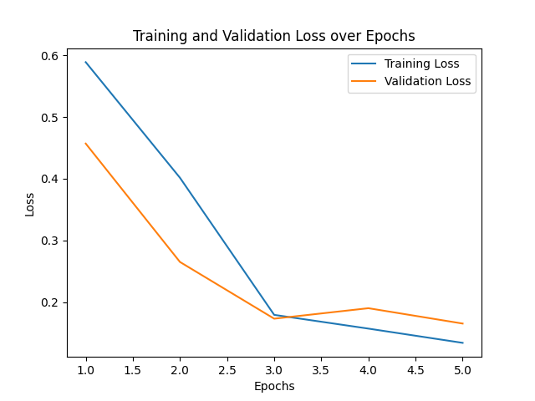
the efficacy of our chosen techniques, data augmentation, and transfer learning.
Our goal in the future is to collect and merge a larger number of datasets in an attempt to reach a dataset that collects at least almost all major types of plants and then use them in deep learning models such as transformers to reach an accuracy of almost 100%. We aspire to use this model in a multi-tasking agricultural research robot that detects plant diseases. It collects images to form an accurately and reliably classified dataset and performs pesticide spraying, plant pruning, and other tasks.

References
- Platforms with Adaptive Batching. Retrieved from University of Houston: https://www2.cs.uh.edu/~fyan/Paper/Feng-SC20-BATCH.pdf

- ARUN PANDIAN J, G. G. (2019, April 18). Data for: Identification of Plant Leaf Diseases Using a 9-layer Deep Convolutional Neural Network. Retrieved from mendeley data: https://data.mendeley.com/datasets/tywbtsjrjv/1

- Connor Shorten, T. M. (2019, july 6). A survey on Image Data Augmentation for Deep Learning. Retrieved from Journal of Big Data: https://journalofbigdata.springeropen.com/articles/10.1186/s40537-019-0197-0

- Mingxing Tan, Q. V. (2019). EfficientNet: Rethinking Model Scaling for Convolutional Neural Networks. Retrieved from Cornell University: https://arxiv.org/pdf/1905.11946.pdf

- Norman P. Jouppi, C. Y. (2017, June 26). In-Datacenter Performance Analysis of a Tensor Processing Unit. Retrieved from Cornell University: https://arxiv.org/ftp/arxiv/papers/1704/1704.04760.pdf

- Nutan. (2023, Jan 21). Transfer Learning Using Feature Extraction In Deep Learning. Retrieved from medium: https://medium.com/@nutanbhogendrasharma/transfer-learning-using-feature-extraction-in-deep-learning-afd97380c96c

- Pranav Subramani, N. V. (2021). Enabling Fast Differentially Private SGD. Retrieved from openreview: https://openreview.net/pdf?id=hw2VfWAr6t6

- riyaz, s. (n.d.). Rice Leafs Dataset. Retrieved from Kaggle: https://www.kaggle.com/datasets/shayanriyaz/riceleafs

- Zafar Salman, A. M. (2023, Aug 1). Crop-saving with AI: latest trends in deep learning techniques for plant pathology. Retrieved from National Library of Medicine: https://www.ncbi.nlm.nih.gov/pmc/articles/PMC10433211/

- Zaid: Seaborn. (2022). Seaborn: Statistical data visualization. https://seaborn.pydata.org/

- Chollet, F., et al. (2015). Keras . https://keras.io/

- Abadi, M., et al. (2015). TensorFlow https://www.tensorflow.org/

- McKinney, W. (2010). pandas: powerful data structures for data analysis. https://pandas.pydata.org/

- van der Walt, S., et al. (2011). NumPy https://numpy.org/

- Pedregosa, F., et al. (2011). scikit-learn: Machine learning in Python. https://scikit-learn.org/

- Kaggle. (2022). Kaggle: Your machine learning and data science community. https://www.kaggle.com/

- Google. (2022). Google Colab: Free, cloud-based Jupyter notebooks. https://colab.research.google.com/

- Zaid: Aburasheid, Z., Ahram, Z., Ibrahim, I., & Ahmad. (2024). deep-learning- Repository. GitHub. https://github.com/Zomo8282/deep-learning
- B. L. Upchurch, E. S. Furgason, G. E. Miles and F. D. Hess, "Ultrasonic Measurements for Detecting Damage on Agricultural Products," IEEE 1985 Ultrasonics Symposium, San Francisco, CA, USA, 1985, pp. 990-993, doi: 10.1109/ULTSYM.1985.198662.
https://ieeexplore.ieee.org/document/1535602
- T. Rumpf, A.-K. Mahlein, U. Steiner, E.-C. Oerke, H.-W. Dehne, L. Plأ¼mer, Early detection and classification of plant diseases with Support Vector Machines based on hyperspectral reflectance, Computers and Electronics in Agriculture,Volume 74, Issue 1,2010,ISSN 0168-1699,https://www.sciencedirect.com/science/article/pii/S0168169910001262

- EffectorP: predicting fungal effector proteins from secretomes using machine learning Jana Sperschneider, Donald M. Gardiner, Peter N. Dodds, Francesco Tini, Lorenzo Covarelli, Karam B. Singh, John M. Manners, Jennifer M. Taylor First published: 17 December 2015 https://nph.onlinelibrary.wiley.com/doi/full/10.1111/nph.13794

- S. Ramesh et al., "Plant Disease Detection Using Machine Learning," 2018 International Conference on Design Innovations for 3Cs Compute Communicate Control (ICDI3C), Bangalore, India, 2018, pp. 41-45,doi:10.1109/ICDI3C.2018.00017. https://ieeexplore.ieee.org/abstract/document/8437085?casa_token=Ds5CbvxcZsIAAAAA:cSaYg1jkhSk8pyBu_ya20Or2kygoYJSPvlVSts4-K310zrVUZUIoh9eKyCrj896UZCjHFE4DVC8

- Resti, Y., Irsan, C., Putri, M. T., Yani, I., Ansyori, A., & Suprihatin, B. (2022). Identification of Corn Plant Diseases and Pests Based on Digital Images using Multinomial Naïve Bayes and K-Nearest Neighbor. *Science & Technology Indonesia*.or URL https://www.sciencetechindonesia.comindex.php/jsti/article/view/415/211)

- Indian Journal of Agricultural Sciences 90 (2): 249–57, February 2020/Review Article
https://www.researchgate.net/profile/Rajni-Jain-4/publication/346943597_Plant_disease_identification_using_Deep_Learnng_A_review/links/5fd346d892851c00f86736c6/Plant-diseaseidentification-using-Deep-Learning-A-review.pdf

- Nigam, S., & Jain, R. (2019). Plant disease identification using Deep Learning: A review. *Indian Journal of Agricultural Sciences*, 201, URL (
- X. Zhang, Y. Qiao, F. Meng, C. Fan and M. Zhang, "Identification of Maize Leaf Diseases Using Improved Deep Convolutional Neural Networks," in IEEE Access, vol. 6, pp. 30370-30377, 2018, doi: 10.1109/ACCESS.2018.2844405.
Hang, J., Zhang, D., Chen, P., Zhang, J., & Wang, B. Classification of Plant Leaf Diseases Based on Improved Convolutional Neural Network.
https://www.mdpi.com/1424-8220/19/19/4161

- Konstantinos P. Ferentinos,Deep learning models for plant disease detection and diagnosis,Computers and Electronics in Agriculture,2018 https://doi.org/10.1016/j.compag.2018.01.009.

- Front Plant Sci. 2023; 14: 1224709. Published online 2023 Aug 1. doi: 10.3389/fpls.2023.1224709
Comparison of image classification models and results. https://www.ncbi.nlm.nih.gov/pmc/articles/PMC10433211/table/T4/?report=objectonly

- AUTHOR=Xie Xiaoyue, Ma Yuan, Liu Bin, He Jinrong, Li Shuqin, Wang Hongyan
TITLE=A Deep-Learning-Based Real-Time Detector for Grape Leaf Diseases Using Improved Convolutional Neural Networks JOURNAL=Frontiers in Plant Scienc YEAR=2020
URL=
DOI=10.3389/fpls.2020.00751

